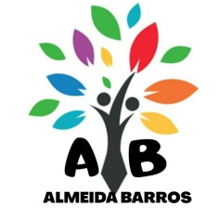

**MATÉRIA PARA O TESTE**

701

Connectors – (but, them, and, so,or) - cap. 4 - Page 14

-Object pronoun - cap.3 10,15 (n° 1 e 2)

-Occupations - cap. 4 - Pages 22, 23, 28