Colégio Evangélico Almeida Barros

Data: 07/04/2020 3º ano do Ensino Médio

Profª Ester Paiva Sociologia: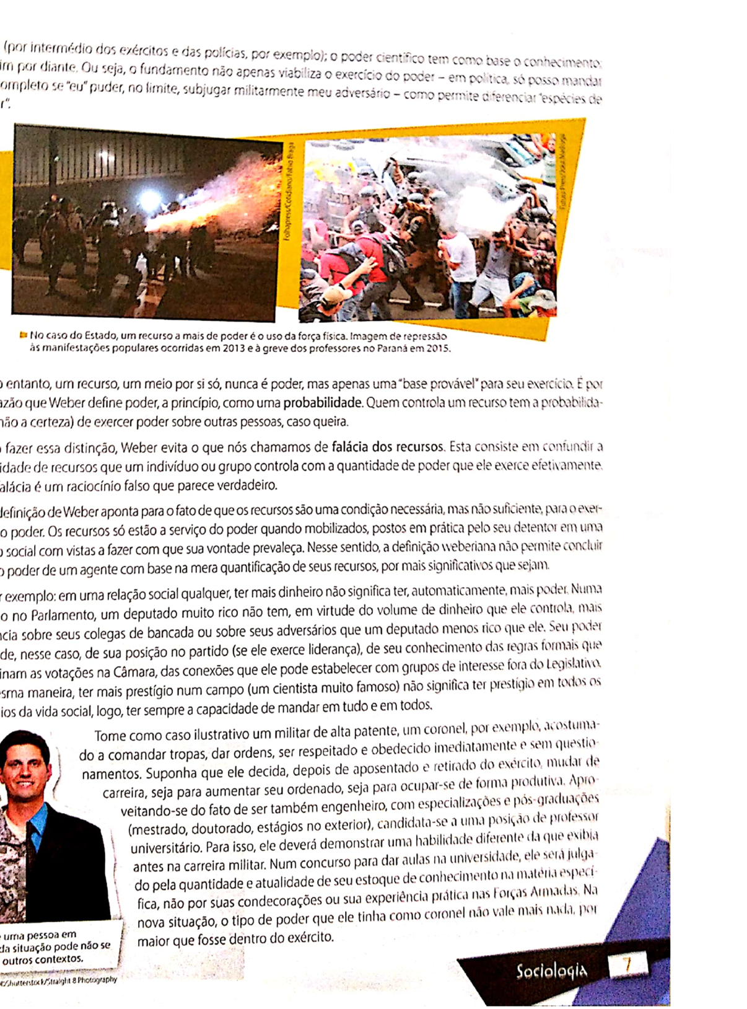

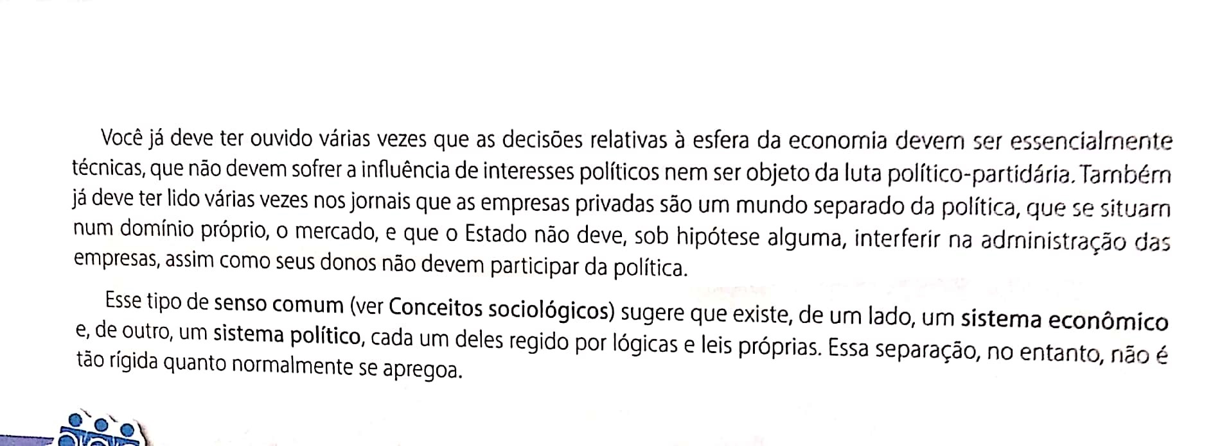

1. Qual é a diferença básica entre os conceitos de poder e dominação para Max Weber?

__________________________________________________________________________________________________________________________________________________________________________________________________________________________________________

2. Explique o que são fundamentos do poder. __________________________________________________________________________________________________________________________________________________________________________________________________________________________________________

3. O que é a falácia dos recursos?

________________________________________________________________________________________________________________________________________________________________________________________________________________________________________________________________________________________________________________________